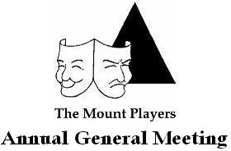  
 **Proxy Form 2022**

**Inc. No: A00017185**  
  
 

I………………………………………………………………… (Please print)

Signature:………………………………………………………  
   
   
Nominate: …………………………………………………… (Please print)

Date: ………………………………………  
   
   
To hold a Proxy vote for me at The Mount Players Annual General Meeting February 7th, 2022.  
   
   
 